For Arz-e-Pak, I’d make the portal feel like a premium AI-powered property platform rather than a traditional property listing website. Keep your existing emerald green, gold, and white branding, but add modern interactive elements, smart maps, and personalized property discovery.
Here are the features I’d prioritize.

Modern design elements for your homepage
Here’s a more advanced homepage concept for Arz-e-Pak, with an AI recommendation panel, Pakistan map, smart filters, and a premium property-search experience.

1. Six features that will make your portal stand out
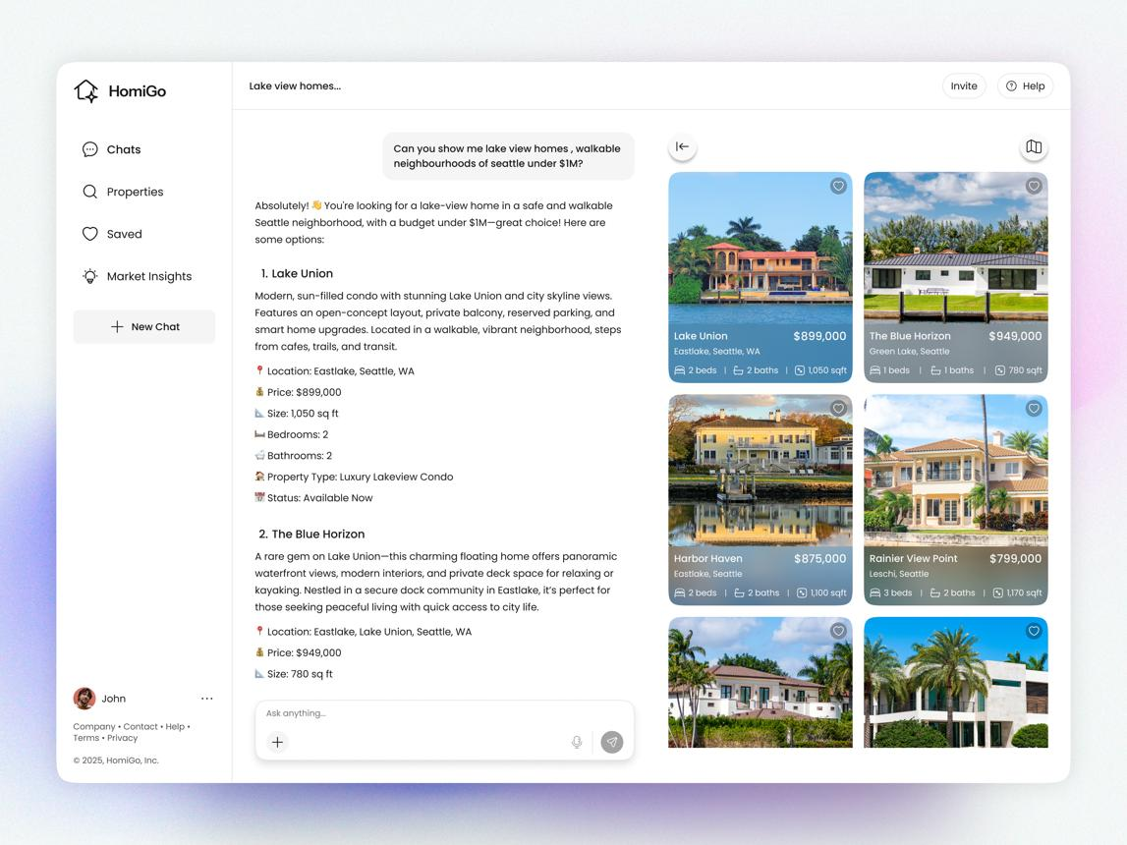
1. AI property assistant
Let users type naturally: “Find a 10-marla house in Islamabad under PKR 4 crore.” Return matching properties and explain why they fit.
High priority
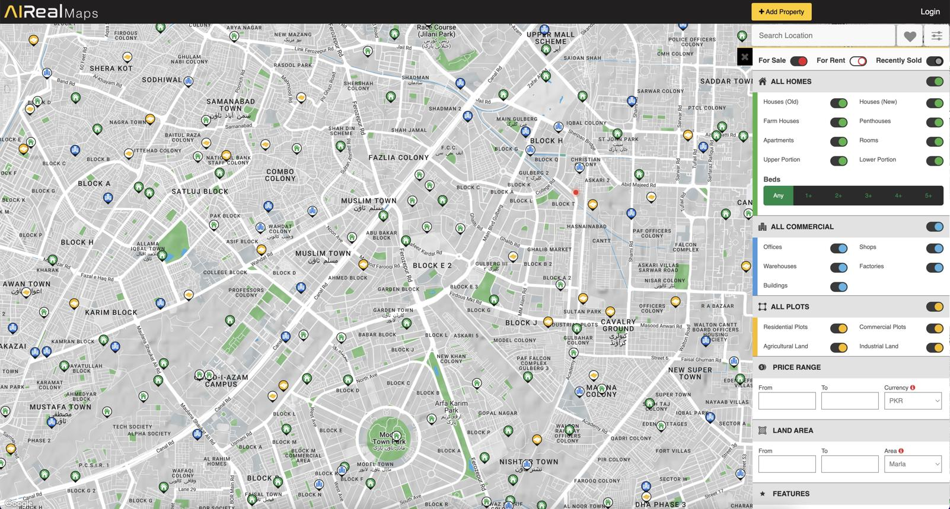
2. Interactive GIS map
Show properties on a map, with nearby schools, hospitals, roads, landmarks, and distances. Your existing GIS functionality could power this feature.
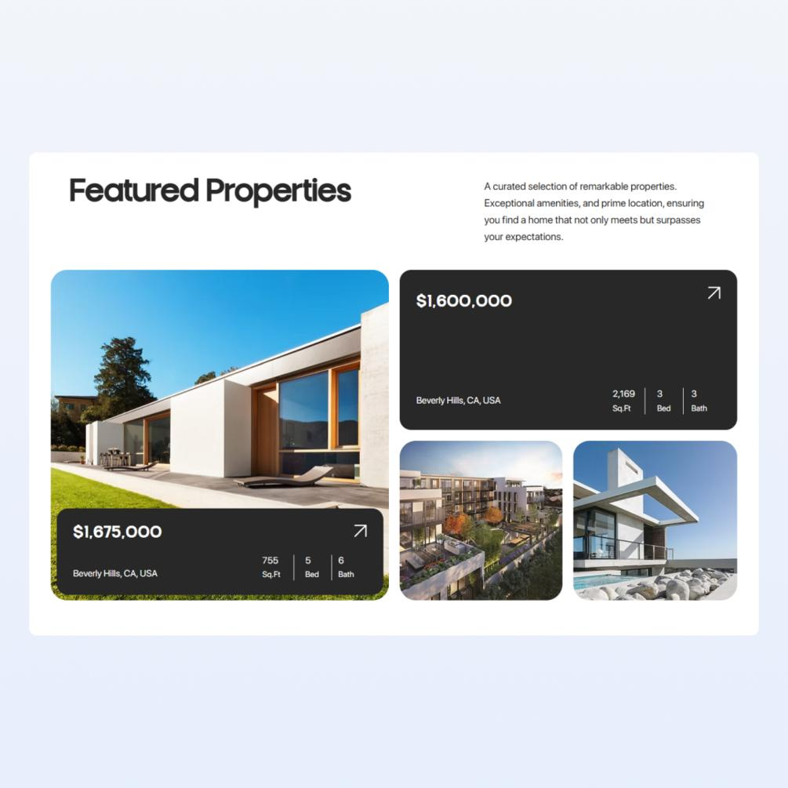
3. Premium property cards
Large photographs, clear PKR prices, area in marla or kanal, bedrooms, location, verification status, and save-to-favorites controls.
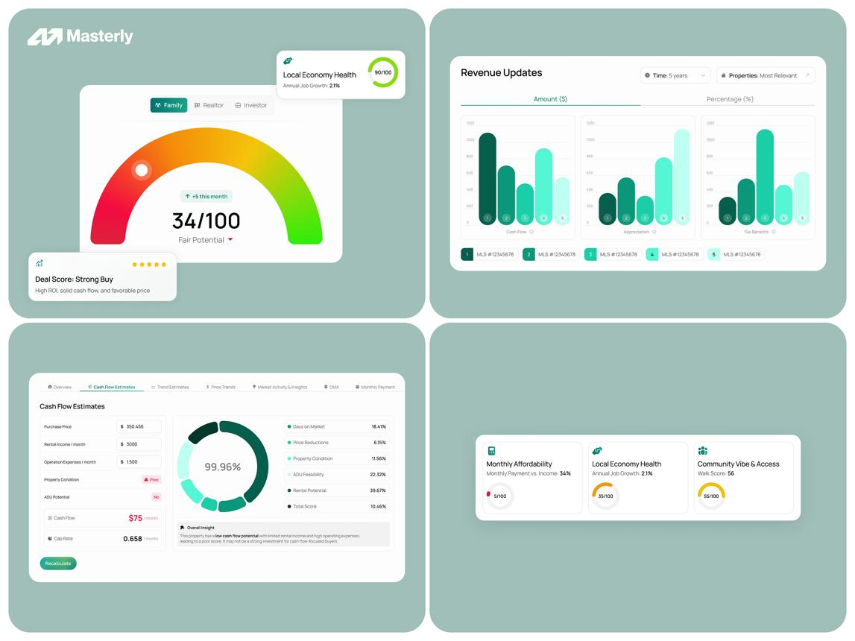
4. Property market intelligence
Add price trends, area comparisons, price-per-marla estimates, and housing-scheme insights. Clearly label estimates and show the data source and date.
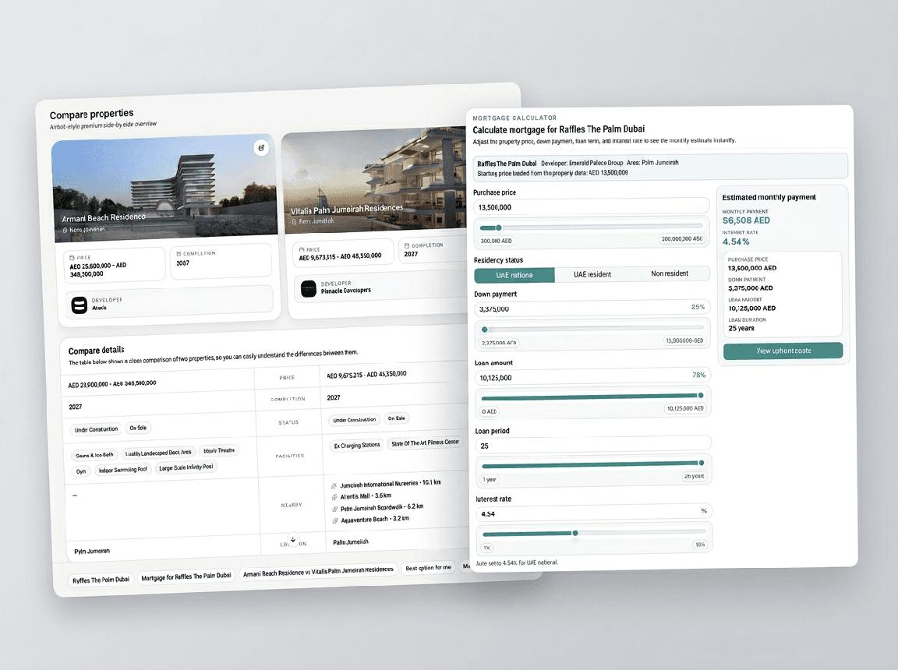
5. Smart comparison
Allow users to compare three or four properties by price, size, location, facilities, and estimated investment metrics.
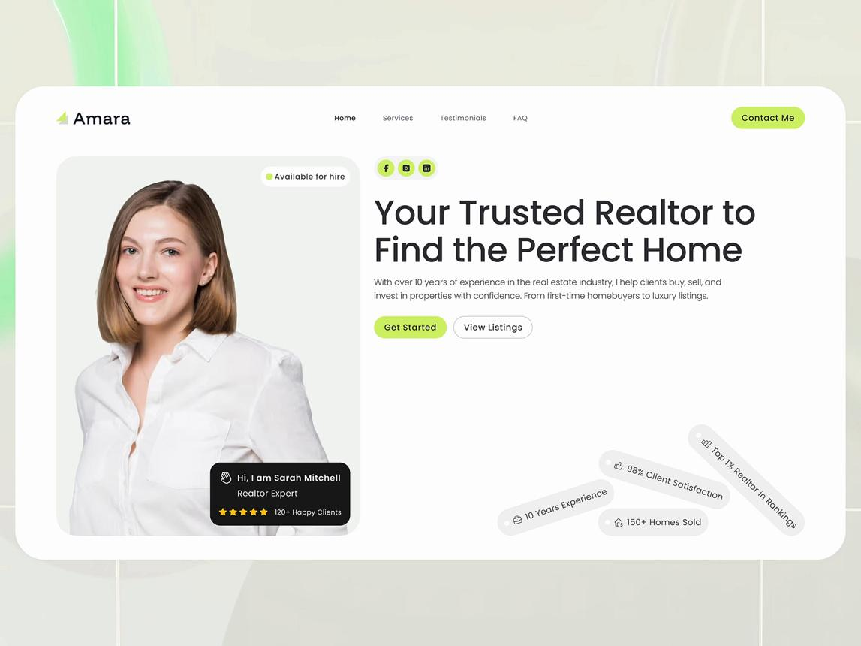
6. Trust and verification
Display verified-agent badges, listing update dates, duplicate-listing checks, and a way to report suspicious properties. Verification badges should only be awarded after actual checks.

2. Recommended homepage layout
I would arrange the page in this order:
ARZ-E-PAK

Find the Perfect Property with AI
Search homes, plots, housing schemes and investment opportunities.
City, housing scheme, area or property...
AI Property Assistant
Natural-language search and personalized matches
Explore Properties on Map
Map pins, neighborhoods and nearby amenities
Featured Properties
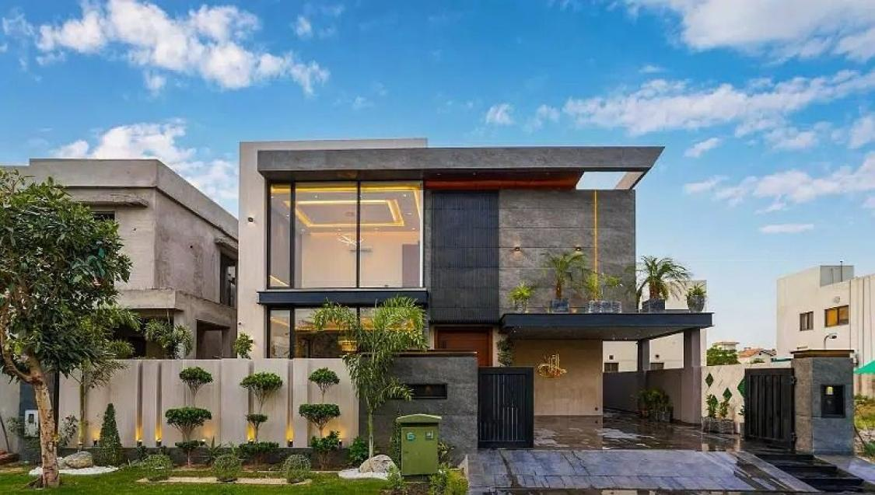
Houses
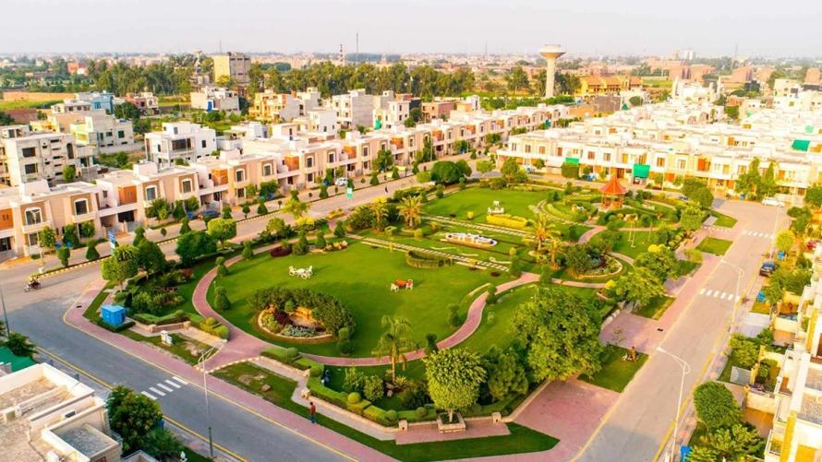
Plots
Market Insights
Price trends, comparisons and investment analysis

3. Small details that make a big difference
- Smooth hover effects and subtle transitions, not excessive animations.
- Glass-style panels over the hero image, with readable text and strong contrast.
- A persistent search bar and clearly visible Buy, Rent, Plot, and Commercial filters.
- Urdu and English language switching with correct right-to-left layout.
- Mobile-first responsive cards, fast-loading images, and a clean navigation menu.
- Saved searches and alerts when matching properties are added.
- Real statistics only. The numbers in design mockups are illustrative and should never be presented as actual portal metrics.

4. What I would build first for your existing project
Because your backend already includes MCP tools for property search, GIS, memory, and RAG, I would prioritize these three features:
- AI natural-language property search powered by your RAG/search tools.
- Interactive property map powered by your GIS coordinates and nearby-search tools.
- Personalized recommendations using saved preferences and property comparisons.
These features would give Arz-e-Pak a stronger identity than simply copying the layout of a conventional real estate listing site.

